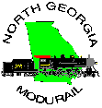
Module Specifications

Adapted from NMRA & Piedmont Division Standards
NMRA Compatible
Release 4.0
September, 1998
© 1998 NGM, Inc.
Copyright 1998 North Georgia Modurail, Inc.
with portions copyright 1990,94 NMRA Piedmont Division
(Special Thanks to Dick Burt, Piedmont Division)

Table of Contents
Table of Contents 2
Introduction 4
Revision History 5
Track Work 6
1.0 NGM Module Track Work Standards Sheets 6
Track Work Standards TWS 1.0 6
Track Work Standards TWS 1.1 7
1.2 Track Work Reference 8
1.2.1 Track Work: Requirements 8
1.2.2 Switch Machine 8
1.2.3 Mainlines 8
1.2.4 Module Interface Tracks 8
1.3 Track Work: Recommended Practices 8
1.3.1 Uncouplers 8
1.3.2 Through Tracks 8
1.3.3 Transition 8
1.3.4 Switches 8
Electrical 9
2.0 NGM Electrical Standards Sheets 9
2.0.1 Wiring Color Code Specification ES 1.0 9
2.0.2 Wire and Plug Specifications ES 1.1 9
2.0.3 AC Power Source Specifications ES 1.2 10
2.1 Electrical Reference 10
2.1.1 General Electrical Standards 10
2.1.2 Wiring 10
2.1.3 Connections 10
2.1.4 Branch Line Electrical Isolation 11
2.1.5 Provision for Accessory Power 11
Frame Work 12
3.0 Framework: General 12
3.1 Framework: Requirements 12
3.1.1 Frame Dimensions 12
3.1.2 Framework: Recommended Practices 12
Scenery 13
4.0 General 13
4.1 Sky Board 13
Rolling Stock 14
5.0 Cars and Equipment 14
5.1 Coupler Type: Recommended Practice 14
5.2 Coupler Height: Recommended Practice 14
5.3 Car Weight: Recommended Practice 14
Diagrams 15
D-1 NGM Track Standard (Recommended) 15
Also showing NMRA Track Standard (for reference only.) 15
D-2 Leg Construction (Recommended.) 16
D-3 Basic Frame Construction (Recommended.) 17
D-4 Corner Module Dimensions 18
Showing exterior frame dimensions and track placement only. Consult NGM for construction details. 18
D-5 Wiring Diagram for Branchlines 19
Allowing analog throttle operation for branchline. 19
D-6 Wiring Configuration Diagram 20
Showing wire color code and pin numbers. 20
Command Control 21
6.0 Command Control Overview 21
6.1 Command Control Bus Wiring 21
6.1.1 Power Pack Isolation 21
6.2 Command Control Terms and Definitions 21
Definitions 24

Introduction
This document describes the standards, requirements and recommended practices of the North Georgia Modurail group. It documents the requirements a module must meet to interchange with other NGM modules.
An NGM module is a lightweight, portable, interchangeable section of a larger layout that, when assembled together, forms a layout capable of handling continuously running trains. While mated modules are common, individual modules are considered to be stand-alone dioramas that may be placed anywhere in the layout.
The intent of these standards is to allow a wide range of individual expression while providing a vehicle for model railroaders to get together to run trains. It provides an excellent method for those with novice skills to learn from the more experienced through workshops and operating sessions. It provides a method with which to promote the fellowship of the hobby and to spark an interest in those who feel they haven't the room for a layout in their home.

Revision History
{Research in progress.}

Track Work

1.0 NGM Module Track Work Standards Sheets
The NMRA Standards printed here are taken from published NMRA Standards MS-1.0, Revised Jan, 1990. The NGM Standards are derived from the Piedmont Division Standards and have been modified to suit the operating conditions of NGM.

Track Work Standards TWS 1.0
Item | NMRA Std. | NGM Std.
Type | Hand Laid or Commercial | Hand Laid or Commercial
Size
Mainline | HO Code 100 | HO Code 100
Auxiliary | N/A | HO Code 100
Other | N/A | HO Code 70 (Minimum)
Set Backs
East/West Ends | 4 ½” | 1 ½”
From Front
Mainline #1 | 5" | 5" or 2 ½” min.
Mainline #2 | 7" | 7" or 4 ½” min.
Auxiliary | N/A | 9 ½” or 7" min.
Centerline Spacing
Interface Area
Mainlines 1 & 2 | 2" | 2"
Auxiliary | N/A | 2 ½” from Mainline #2
Non Interface Area
Mainlines 1 & 2 | 2" min. | 2" min.
Auxiliary | N/A | 2 ½” min.
Curves | 2 ½” track centerline at all points except transition to 2" approaching parallel track | 2 ½” track centerline at all points except transition to 2" approaching parallel track
Elevation | 40" from floor to top of mainline railheads within interface area | 40" from floor to top of mainline railheads within interface area

Track Work Standards TWS 1.1
Item | NMRA Std. | NGM Std.
Clearances
Horizontal
Straight Track | 1 ¹/₃₂” | 1 ¹/₃₂”
Curved Track | N/A | 1 ¼”
Vertical | 3" | 3 “
Interface Track Length | 9" | 3"
Parallel Tangent Track (Min.) | 3" | 3"
Grade (Max.)
Mainline | 3% | 0%
Auxiliary | N/A | 3%
Branch Line | N/A | 3%
Turnouts (Min. size)
Mainline | #6 | #6
Auxiliary | N/A | #6 ⁵
Branch Line | N/A | #4
Curve Radius (Min.)
Corner Module
Mainline | 34 ½” | 37"
Auxiliary | 32” | 35"
Branch Line | N/A | 32"
Straight Module
Mainline | 32" | 32"
Auxiliary | N/A | 29 ½”
Branch Line | N/A | 18"
"Industrial" | 24" | N/A
Uncouplers
Permanent Magnet | Not for use on mainlines | Not for use on mainlines

1.2 Track Work Reference
The following track work information applies to all NGM modules. They apply regardless of size or type.

1.2.1 Track Work: Requirements
To be compatible with existing NGM modules, it is a requirement that one adhere to either the NMRA Standard or the NGM Standard.

1.2.2 Switch Machine
Manual ground throws or electrical switch machines may be used to control switch position. The only requirement is that all switch devices shall positively lock the switch machine in either position when set.

1.2.3 Mainlines
Two mainlines shall be required, located as shown in diagram D-1. The club is supportive of modules that provide an auxiliary mainline but it is not required.

1.2.4 Module Interface Tracks
9" standard Snap-Track sections will be used on interface areas that use the NMRA standard 4 ½” interface area. 3" and 6" sections will be used to connect NGM to NGM modules and NGM to NMRA modules respectively.

1.3 Track Work: Recommended Practices

1.3.1 Uncouplers
Kadee's #307 (switched) electromagnetic uncoupler (or equivalent) is acceptable on the mainline tracks, so long as it is properly installed and does not interfere with the passage of trains.

1.3.2 Through Tracks
The minimum required number of through tracks is 2. An auxiliary through track should be considered to allow for a third mainline. When providing information about your module, please be sure to provide the auxiliary track type, that is, Mainline #3 or branch line. Providing for the third mainline remains optional.

1.3.3 Transition
Use of code 83 rail or smaller should have a 2 ½” transition track before meeting with mainline code 100 rail. (Transition should not occur at a switch joint.)

1.3.4 Switches
Switches with positive locking action are preferred over the more common slide action switches. This style mechanism is most commonly found on switches made by PECO. If a switch without positive lock is installed, it is highly recommended that it be driven by a switch machine that resists accidental movement; for example, a Tortoise™ motor driven switch machine.

Electrical

2.0 NGM Electrical Standards Sheets
In the following specifications either the NMRA standard or the NGM standard are required for electrical wiring on modules

2.0.1 Wiring Color Code Specification ES 1.0
Wire Connection | NMRA Std. | Pin # | Old NGM Std. | Pin # | NGM Std. | Pin #
S. Main, S. Rail | RED | 1-1 | RED | 1-3 | RED | 5
S. Main, N. Rail | GRN | 1-2 | GRN | 1-1 | GRN | 3
N. Main, S. Rail | BLU (BLK) | 2-1 | BLU (BLK) | 1-4 | BLU | 2
N. Main, N. Rail | YEL (WHT) | 2-2 | YEL (WHT) | 1-2 | YEL | 7
Aux. Main, S. Rail | N/A | N/A | ORG (GRY) | 2-2 | ORG | 9
Aux. Main, N. Rail | N/A | N/A | BRN | 2-1 | BRN | 6
DCC Common | N/A | N/A | N/A | N/A | GRY | 8
18VAC-1 | N/A | N/A | N/A | N/A | BLK | 4
18VAC-2 | N/A | N/A | N/A | N/A | WHT | 1

2.0.2 Wire and Plug Specifications ES 1.1
Item | NMRA Std. | Old NGM Std. | NGM Std.
Throttle Bus Wire | N/A | NGM provided | NGM provided
Throttle Bus Plug | N/A | NGM provided | NGM provided
Throttle Bus Socket | N/A | NGM provided | NGM provided
Feeder Wire | N/A | 16-20 AWG ⁷ | 16-20 AWG
Main Electrical Bus Wire | 18 AWG | 14 AWG | 14 AWG
Left (West) Connector | Jones 2 pin Female | Jones 4 pin Female | N/A
Right (East) Connector | Jones 2 pin Male | Jones 4 pin Male | N/A
Main Electrical Bus Plug | N/A | N/A | ATA 9-Pin
Main Electrical Bus Socket | N/A | N/A | ATA 9-Pin

2.0.3 AC Power Source Specifications ES 1.2
Item | NMRA Std. | Old NGM Std. | NGM Std.
Type | 110VAC UL Approved, Heavy Duty grounded multi-outlet strip. | 110VAC UL Approved, Heavy Duty grounded multi-outlet strip. | 18VAC tap from Main Electrical Bus
Orientation | Male to East End  Strip at West End | Male to East End  Strip at West End | N/A
Capacity | 15 amp | 15 amp | 500 mA draw max.
Wire Size | 14 AWG | 14 AWG | 14 AWG on bus  18 AWG on module

2.1 Electrical Reference

2.1.1 General Electrical Standards
Each module shall connect to the Main Electrical Bus via the ATA 9-Pin connector providing power for at least two mainlines and shall be wired according to the wiring diagram provided in this document. It is not required that mainlines have module to module isolation but branchlines should be isolated from the mainline with plastic insulating rail joiners.
An NGM modification to the NMRA standard for Main Electrical Bus Wiring is the use of 14 AWG electrical wire on HO modules. This wire size allows for high current capacity, low signal loss, and high physical strength. (See NMRA Standard MS 1.3 Electrical standards for Modules, All Scales.)

2.1.2 Wiring
The Main Electrical Bus shall consist of a nine (9) wire cable forming a robust electrical backbone to which each module is connected by feeders. This cable shall provide three (3) pairs of 14 AWG wire to power two (2) mainlines and one (1) auxiliary mainline, one (1) 14 AWG wire to serve as the DCC booster common and one (1) pair of 14 AWG wires to provide 18VAC. Each module need only provide wiring for local track and power requirements, (see diagram D-6 for pin wiring and color code.)
Throttle Bus wiring will be provided and installed by NGM if requested.
Provisions should be made to ensure that all wiring can be properly stowed for transport. In other words, no dangling wires.

2.1.3 Connections

2.1.3.1 Terminal Strips
It is recommended that all module wiring be accessible using a terminal strip between the 9-pin connector and the rest of the module. This will allow for easy socket maintenance, the ability to easily add NMRA plug assemblies and also provide a convenient location for electrical testing with a voltmeter.

2.1.3.2 Main Electrical Bus Connectors
The ATA 9-pin socket shall be mounted towards the back of and as close to center (East-West) as possible on modules up to 6’ long. On longer modules the socket shall be mounted 3’ from the West end (closest joist is acceptable.) Use a mounting bracket (Pollock #12-701) and orient the socket facing downward as much as possible giving proper clearance for exit wires and not allowing the connector to hang below the module frame.
NGM will stock these connectors and wire for use in members’ modules at a nominal fee.

2.1.3.3 Plug Adapters
When connecting to a standard NMRA module, an adapter must be used to break out the individual mainlines into the 2-pin plugs used by NMRA. It is intended that NGM will have these adapters available to members who have followed the NMRA standards. This would be the case if a new member joined with an existing module from another club.

2.1.4 Branch Line Electrical Isolation
Optional sidings and passing tracks must be electrically isolated if analog throttles are used for switching off the mainline. Gaps must be installed on both rails. Common-rail wiring is not to be used. Any local controls should be mounted on the module. Removable control panels are permissible. (See Branchline Power Connection Diagram D-5.)
The use of plastic rail joiners is preferred over the cut and fill method (using epoxy to fill a cut in the rails) when installing insulation gaps.

2.1.5 Provision for Accessory Power
The Main Electrical Bus shall provide 18 VAC on the black and white wires. Individual modules may use this power source for optional accessories such as lighting, animation and switch machines. It is recommended that a module limit the current draw to 500 mA, continuous.

Frame Work

3.0 Framework: General
The specifications for module sizes are relatively strict. The following describes the minimum requirements and recommended practices for module framework construction. Modules will be checked annually to ensure conformance to specifications following the NGM Module Compliance Audit Form. Conforming modules will display a dated sticker which will provide sufficient proof of compliance.
As of this revision, the NGM standards committee has not approved the use of transition modules to allow for the inclusion of non-conforming modules.

3.1 Framework: Requirements
For consistency with existing modules, it is recommended the module frame sides and ends will be made with 1" x 4" (³/₄” x 3½” finished ) lumber such as common pine. It shall be straight, solid and free of knots. It shall be sanded smooth prior to finishing and painting. All visible framework must be painted with Ace Hardware Forest Green interior latex paint (or equivalent.) Some provision must be provided for hanging NGM provided decorative curtain or skirting.
Modules are joined by 3" C-clamps. Provision must be made to clamp to any other module whose side frame is a standard 1” x 4”. Two clamps are required for each module end and none will be provided by the club. Two clamps are required to allow front to back track alignment.

3.1.1 Frame Dimensions
Dimension | Min. | Max.
Leg Height | N/A | Adjust with eye bolt to reach 40” at rail  See Diagram D-2 (Leg Construction)
Length | 24" | 96" (in 24" increments)
Depth | 18" | 36"
Height | 3 ½” | N/A
Frame corners must be square

3.1.2 Framework: Recommended Practices
It is recommended that the frame pieces be joined with screws and glue. It is also recommended that the gluing be done on the inside of the framework to eliminate glue residue from marring the appearance of the frame exterior.
If a handle is attached to the module, it should be done on the north side so that it is not seen during shows. The legs should be removable and have a T-nut or threaded insert and eye bolt installed on the floor side to allow for rail height adjustments.

Scenery

4.0 General
The scenery design, style, colors and details are all optional. Each module has the option of being a stand alone diorama or belonging to a set of modules that make up a mated set. The club will not mandate scenery styles nor scenery contents. As a general guideline, a clear majority of NGM modelers have followed a modern, late 1960’s to 90’s theme.

4.1 Sky Board
Each module will have a sky board or backboard that extends 14" above the rear side rail. It should be 1/8" shorter than the module on each end to avoid interference with adjoining modules. The sky board may be permanently attached but it is recommended that it be removable for ease of transportation. (See diagram D-3 for placement.) The sky board must be painted on both sides. NGM recommends the use of Sherwin Williams Universe Blue (or equivalent) for the front of the sky board. Paint the back of the sky board with the same green paint used for the frame (refer to section 3.1.)

Rolling Stock

5.0 Cars and Equipment
The requirements for rolling stock which will be used during a specific setup of the layout may be determined in advance by the setup coordinator. If equipment being used on the layout is performing in a manner deemed by the setup coordinator to not be sufficiently reliable, he/she may order it removed from the layout until the condition has been corrected.

5.1 Coupler Type: Recommended Practice
It is recommended that the coupler type be a KADEE style coupler. All couplers will be checked for free movement and the centering spring should be fully functional.
EXCEPTION: Trains that operate as a single unit, such as passenger trains, may utilize any coupler type available, since interaction with other cars will not occur.

5.2 Coupler Height: Recommended Practice
All cars will be checked on the test track prior to placing them on the layout. The test track will have KADEE coupler height gauges to verify proper coupler height. Cars not meeting the proper height may not be approved for operation on the layout. The test track will be provided by the club.

5.3 Car Weight: Recommended Practice
Cars should be weighted according to the NMRA recommended practice RP-20.1.
Portions of RP-20.1 are reprinted here:
SCALE | Initial Weight |  | Additional Weight Per Inch of Body Length
HO | 1 ounce | + | ½ ounce
To figure the optimum weight of a given car, take measurements of the car with a standard ruler. Multiply the length of the car in inches by .5 and then add 1. This will be the optimum weight of the car. If the car is light weight add the difference in lead weights until desired weight is achieved.
EXAMPLE:
A 50 ft car weighs 2 ounces and the car is roughly 7" long. The optimum weight is figured as follow: 7x.5 (3.5) ,+1 (4.5), -2 (2.5) The difference between the initial car weight (2) and the optimum weight (4.5) is 2.5 and it is the amount of weight to add to the car.

Diagrams

D-1 NGM Track Standard (Recommended)

Also showing NMRA Track Standard (for reference only.)
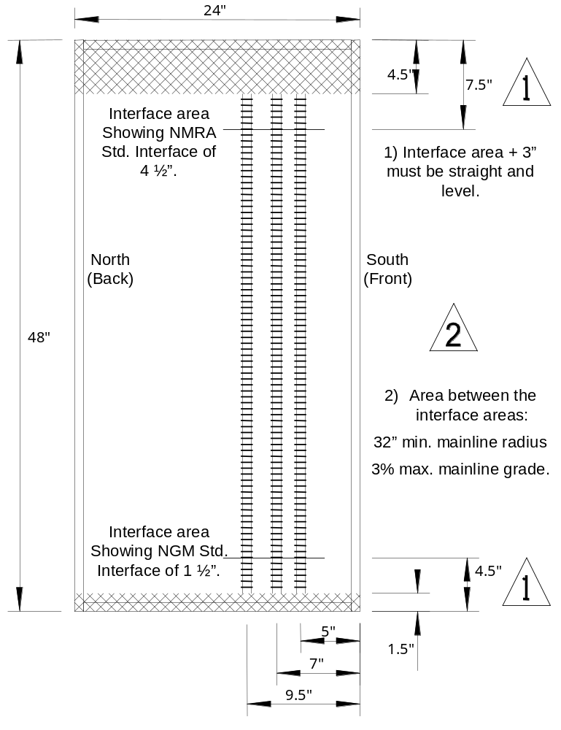

D-2 Leg Construction (Recommended.)

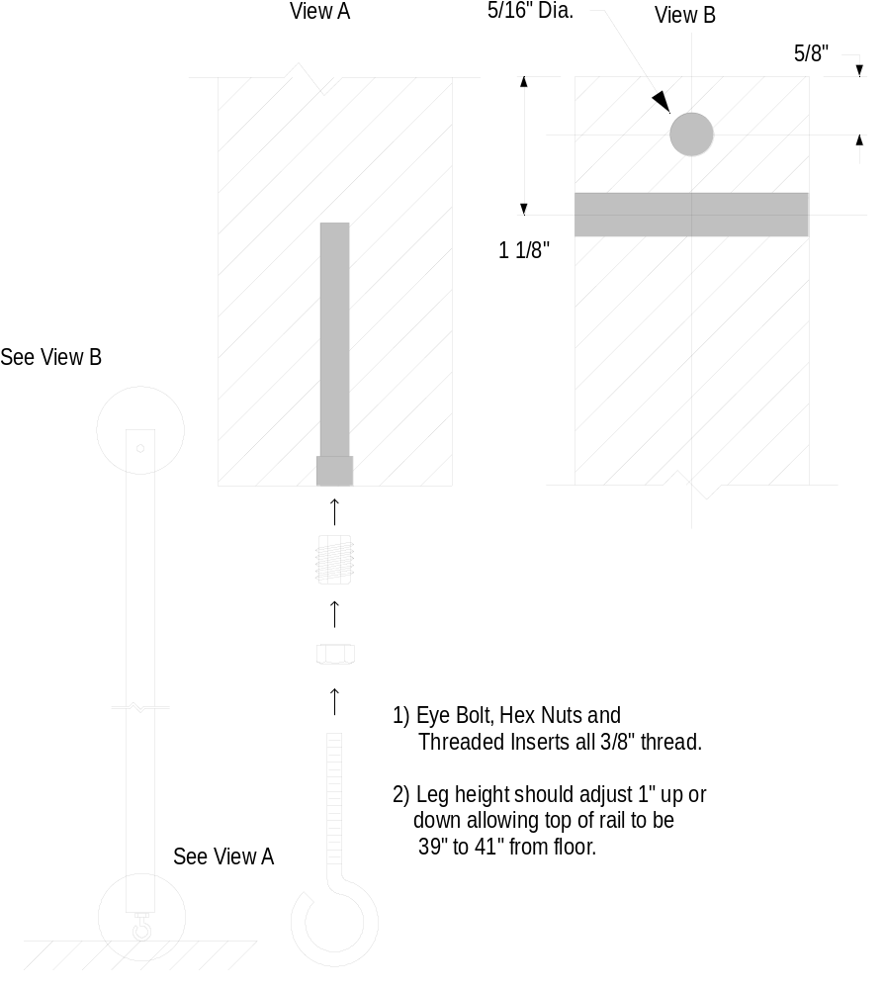

D-3 Basic Frame Construction (Recommended.)

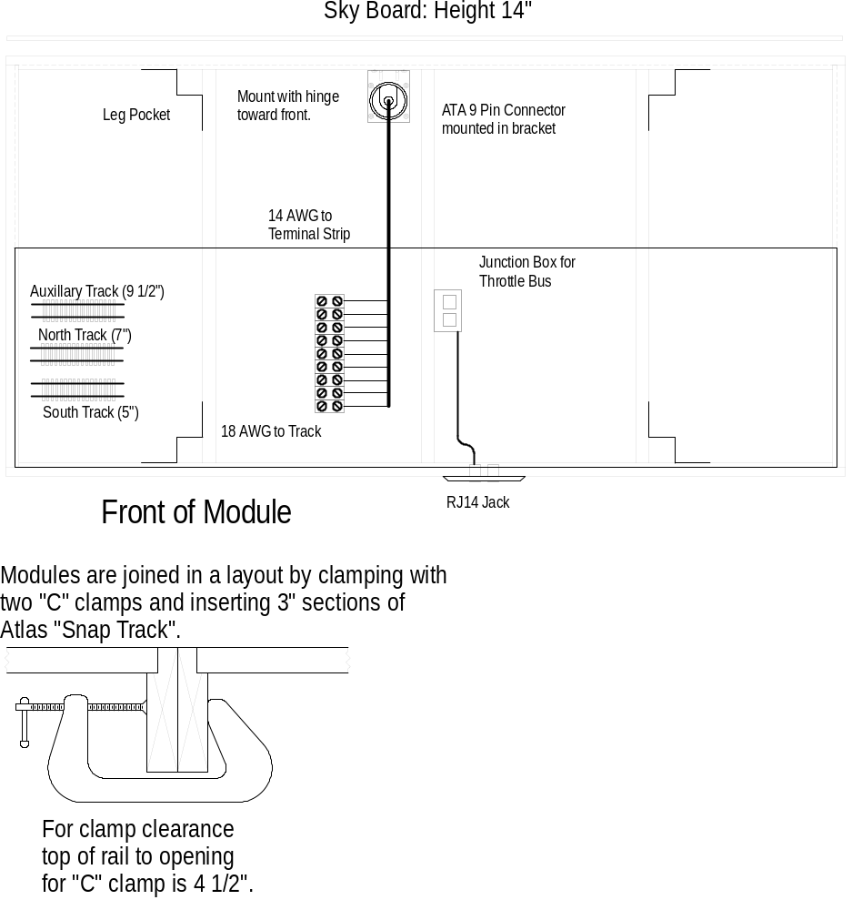

D-4 Corner Module Dimensions

Showing exterior frame dimensions and track placement only. Consult NGM for construction details.
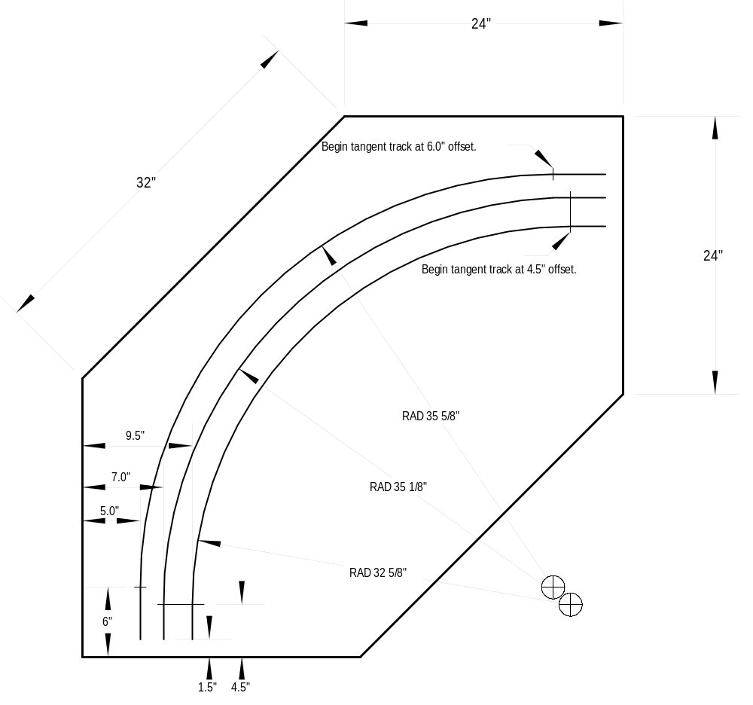

D-5 Wiring Diagram for Branchlines

Allowing analog throttle operation for branchline.
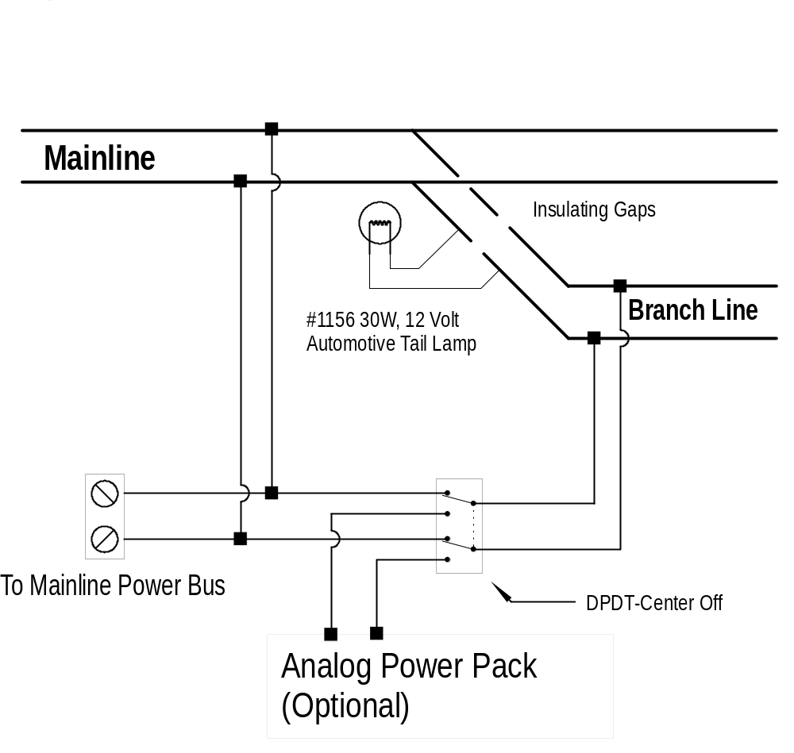

D-6 Wiring Configuration Diagram

Showing wire color code and pin numbers.
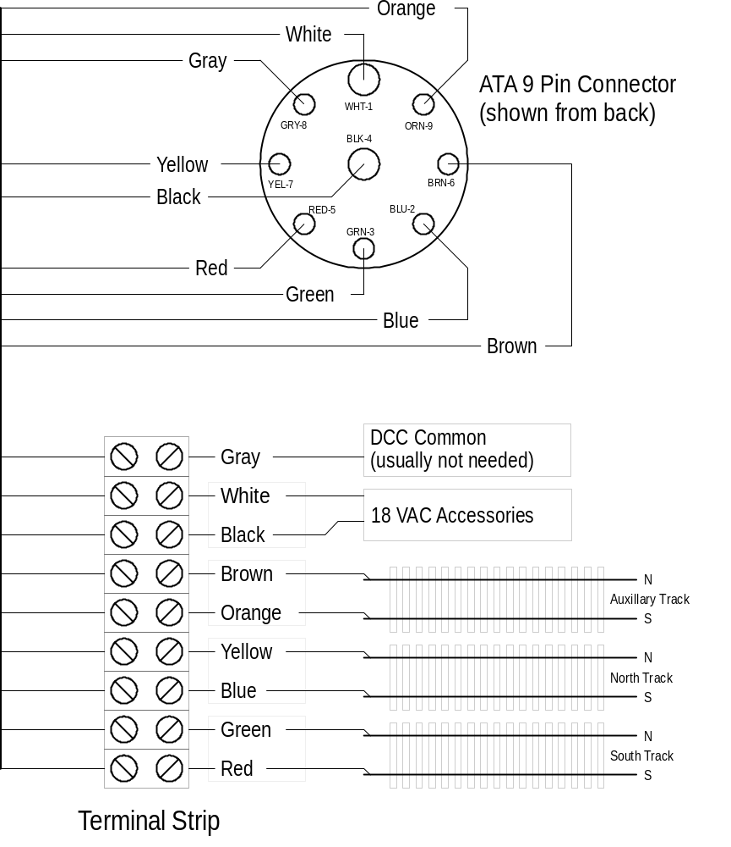

Command Control

6.0 Command Control Overview
The NMRA Electrical Committee: Digital Command Control Working Group has developed a set of standards and recommended practices that define digital command control so that basic interchange of equipment can be obtained between users of different manufacturers of digital command control equipment.
Digital Command Control (DCC) is possible because of new advances in electronics that allow a very smart controller to be installed inside the average locomotive shell. Instead of using a variable power source as in the case of a standard analog throttle, the track becomes a communications device that broadcasts multiple signals from many controllers at once. Each locomotive receiver is pre-programmed to respond to a specific controller, allowing many locomotives on the same section of track, each controlled independently.
The analog throttle we commonly refer to as a power pack is now inside the locomotive. As a result, the track will always have between 7 and 20 volts available across it when measured with a voltmeter. While most non-decoder equipped locomotives will operate with this system, NGM cannot guarantee that damage will not result from this use.
The DCC standard allows compatibility between different manufacturers while at the same time allowing the manufacturer a great deal of freedom and flexibility to create very different products to fill market niches that they feel best qualified to provide.
North Georgia Modurail, Inc. has enthusiastically adopted these standards by purchasing command stations, boosters, decoders and throttles from Digitrax, Inc. of Norcross, Georgia. Digitrax units are compatible with NMRA DCC Standards and Recommended Practices, while still offering additional options and features.

6.1 Command Control Bus Wiring
It is strongly recommended that all new NGM modules provide support for the Throttle Bus. If the module owner would like, NGM will install a socket mounted RJ11-6 jack on either/both the north and/or south faces of the module along with the associated wiring to interface to the Throttle Bus.

6.1.1 Power Pack Isolation
Sections of track that will operate in analog mode (using a standard power pack), should provide some form of isolation. The most common technique is to install a #1156 30W, 12V automotive tail lamp between adjoining track sections (see diagram D-5.)

6.2 Command Control Terms and Definitions
The purpose of this section is to define the nomenclature used in discussing Digital Command Control (DCC). DCC can be assumed to imply compatibility with NMRA DCC Standards and Recommended Practices.
Control Bus
A bus which connects a Command Station to its Boosters.
Cab Bus
A bus used to connect all types of cabs, except wireless cabs, to a command station. Wireless cabs are indirectly connected to a cab bus via their companion wireless cab base.
Booster
A unit which accepts as input a signal from a command station and provides as output a power source onto which is encoded a digital (DCC) packet signal. (Also known as a "Power Station". Digitrax calls it a DB100, for example.) More than one booster may be used on the same layout if additional current is needed for locomotives.
Cab
A unit which presents to a human operator the controls necessary to operate a model locomotive, track switches, or layout accessories. Such controls may include both input devices (knobs, buttons, switches)and output devices (lamps, displays, audible sounding units).
Fixed Cab
A cab which is permanently mounted in a specific location.
Tethered Cab
A cab which is hand-held and connected by a fixed cable to the layout.
Walk-around Cab
A cab which is hand-held and connected by a cable to a plug which may be inserted in jacks at multiple points around the layout. Walk-around cabs permit the locomotive(s) being controlled by that cab to maintain direction and speed during the interval while the cab is unplugged, moved to a new location, and re-plugged. This is because packet transmission is done in the command station.
Wireless Cab
A hand-held cab which has no cable connection to the layout. Wireless cabs may use infra-red, radio, or other means of communicating information.
Wireless Cab Base
A companion receptor unit for one or more wireless cabs which is fixed to the layout and presents cab information to the cab bus
Computerized Cab
A cab which is implemented by a personal computer or workstation.
Panel or Tower Cab
A fixed cab which is primarily used for operating turnouts, signals, and related track accessories. A tower cab may, but typically does not, also control locomotives. Tower panels typically include display devices for indicating track switch positions, track occupancy, and layout status. A CTC board is an example of a tower cab.
Command Station
That unit which accepts input from all cabs currently in use and provides as output either:
- a DCC signal directly to the track, or
- an appropriate signal to drive a Booster to output a DCC signal.
Software Command Station
A command station implemented by software processes in a computer, typically a personal computer or workstation.
Accessory Booster
A Booster whose output is dedicated to the operation of stationary decoders.
Programmer
That unit which provides access to the system configuration functions, such as setting locomotive addresses, combining and breaking up multiple unit lashups, etc. May be integrated with the command station, or with one or more cabs.
Decoder
A unit which accepts address and command information presented in the digital packet format from a Command Station or Booster and directly controls and drives a motor, solenoid, relay, lamp, or other device. (Also known as a "Receiver".)
Mobile Decoder
A decoder which is installed in, and implements the specific functions to drive the motor, lamps, and accessories of a locomotive or other piece of rolling stock. A mobile decoder derives its signal and power from contact with the rails.
Stationary Decoder
A decoder which is installed in a fixed place on the layout and provides power and position control for one or more turnout motors or provides operational control for other stationary accessories on the layout. A stationary decoder may derive its signal and power from the rails or it may be powered from an Accessory Booster.
Decoder Slave
A unit which is driven by a decoder and which provides additional power for the operation of additional electrical load in parallel with the original decoder load. Typical use is for 2nd, 3rd, etc. motors in a multi-motor locomotive or permanently-coupled locomotives. May also be called "Slave Decoder".
Track Segment
That portion of electrically isolated track powered and controlled by a single Booster.
Bus
A set of wires that distributes electrical power or signals around the layout.
Track Bus
A bus which connects a power station to a track segment. The aggregate length of the track segment is limited such that the power station can power the maximum number of locomotives to be simultaneously operated on the segment. Note that stationary decoders may be connected to a track bus. The wire gauge of a track bus must be appropriate to the rating of the associated Booster.

Definitions
The following items define the terms used in this document
AWG
AWG refers to "American Wire Gauge". It is a standard that defines electrical wire sizes by a numerical value. The word "gauge" is commonly used when referring to a wire size.
For the technical types:, 14 gauge wire is 1.628 mm in diameter and has the ability to conduct 17 amps of electrical current while only having 2 ohms or resistance per 1000 feet.
Auxiliary Track
Auxiliary lines serve as an optional third mainline when possible. When used as a mainline, it must be installed with the same standards as the other mainlines. An auxiliary track is always parallel to the mainline at a 2 ½” center from mainline #2 and is also called Mainline #3. When used as a siding, branch line standards apply and it may not be considered as a third mainline if it deviates from the mainline standard.
Branch Lines
These lines are optional on all modules. They must conform to all NGM electrical and interface standards. They must also be insulated from the mainline if a local analog throttle is to be used while the mainline is active.
Bridge Track
A connecting, removable track section used to join the tracks between modules. The interface area has been sized to allow standard sectional track parts to be inserted between modules. (Also known as an Interface Track.)
Center Spacing
The distance between the centerlines of parallel tracks.
Conforming Modules
Modules that are freely interchangeable in every way with all other conforming modules built to these standards. Conformity shall be determined by the NGM Conformance Committee.
DCC
Digital Command Control (DCC). The NGM standard incorporates NMRA approved standards for DCC operation . DCC allows for independent selection and control of engines by sending commands over the rails to miniature microprocessors installed in the engine bodies. The NGM electrical standard requires a telephone style jack to connect the hand-held controller.
East End
This is the right-hand end of the module as seen from the front (the normal viewing side)
West End
This is the left-hand end of the module as seen from the front (the normal viewing side.)
Interface Area
Any portion of the module within 1½" from the East and West ends of the module. (See the Interface Area diagram.) The Interface Area is considerably restricted by the NMRA and NGM standards to ensure that modules are interchangeable and operations are smooth. The NMRA standard defines the Interface Area to be 4½" vs. the 1½" adopted by NGM.
Mainline Track
The standard defines the mainline as two tracks running the length of the module, not including the interface area, that provide eastbound and westbound operation of trains. The mainline is restricted to 5" and 7" centerlines from the front of the module (in the interface area) with some optional variations. The mainline also has strict radius, grade and turnout restrictions to ensure smooth operation.
Mated Set
Any group of modules in which the individual modules cannot be used separately for some reason. Mated Sets typically consist of modules that do not conform to our interface standards between themselves, but conform to the interface standards at both ends of the set.
A variation of a mated set is a group of modules that fully conform to our interface standards but are designed to be joined together due to scene continuity or optional interface area track connections that provide multi module continuity. (Commonly seen in intermodal yard modules.)
Module
A module is a portable section of a table-like frame work which is one part of a large group of similar modules that when assembled together forms a large and fully operating model railroad. They are built by individuals as part of a home layout or specifically for interfacing with others in a large setup. All are built to a set of standards that allow each unit to interface exactly with other units anywhere in the overall system. A module may be a single frame or a set of frames that interface with other modules in a standard manner but that may deviate from the interface standard between ends (see Interface Area.) By being portable, they may be disassembled-assembled for transporting to conventions or public displays. Many clubs are formed for the specific purpose of building module layouts as space for permanent layouts is hard to find and very expensive when available. NGM is such a club.
Non-Conforming Module
Modules that are not built to these standards (in either track arrangement or electrical wiring methods) and therefore not directly compatible with the system as outlined here.
Non-Interface Area
Any portion of the module not within the interface area. Restrictions within the non-interface area are minimal, although extreme variations in grade, turn radius, and track gauge could render the module undesirable.
Route Convention
The southern most mainline (mainline #1) runs eastward and the next parallel mainline runs westward. The auxiliary mainline direction is not defined. NOTE: The viewing side of the module is the south side.

Adjustable from 39" to 41"
Horizontal clearances are from track center. Refer to NMRA Standards S-7 and S-8, Revised Aug. 1982.
Refer to S-8, Class Ia for track radius of 32”.
Use 6” interface track when connecting NGM module to NMRA module.
Use of PECO medium is acceptable.
Colors indicated in parentheses are alternate acceptable colors. Pin # indicates which connector then which pin, e.g. 2-1 means the 2nd connector, pin #1.
18 AWG recommended
Pollack #12-906
Pollack #12-907
Maximum current available to any one module is subject to total current capacity provided by NGM. See layout coordinator for more details.
Note that if Tortoise™ switch machines are to be installed standard 1” x 4” lumber will not provide adequate depth to protect them from damage.
A ¾” Velcro™ strip (hook side) is recommended.
Must be adjustable from 39” to 41”.
Due to standardization, decoders from other DCC compatible manufacturers will work with the club system but extended optional features may not operate.

